**Text**

<link href="https://fonts.googleapis.com/css?family=Lato|Roboto+Condensed|Titan+One" rel="stylesheet">

[Headings](https://support.jimdo.com/elements/basic/heading/)

font-family: 'Lato', sans-serif;

[Navigation Menus](https://support.jimdo.com/design/style/navigation/) and [Horizontal Lines](https://support.jimdo.com/design/style/horizontal-line-styles/)

font-family: 'Titan One', cursive;

[Buttons](https://support.jimdo.com/design/style/button-styles/)

font-family: 'Roboto Condensed', sans-serif;

**Colors**

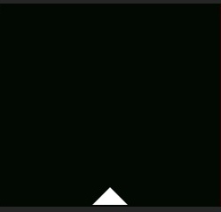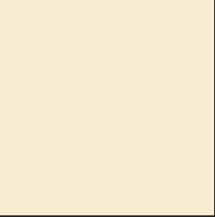

Primary Color for Background

RGB 252 148 29

HEX FC941D

Secondary Color for Boxes

RGB 246 237 209

HEX F6EDD1

Tertiary Color for Text

RGB 2 8 2

HEX 0208020



Color for Headings

RGB 3 2 203

HEX 0302CB

**Buttons**

Default Hover

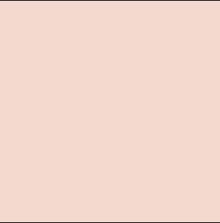

Default Color for Buttons

RGB 128 215 218

HEX 80D7DA

Hover Color for Buttons

RGB 243 217 206

HEX F6EDD1